SESHOP Database Diagram
The following ER diagram is aligned with:
- docs/1.BRD/SESHOP BRD.md
- docs/10.SRS/SESHOP SRS.md
It includes core omnichannel modules: RBAC, catalog, inventory, inbound receiving, order allocation, POS controls, reverse logistics, and invoicing.
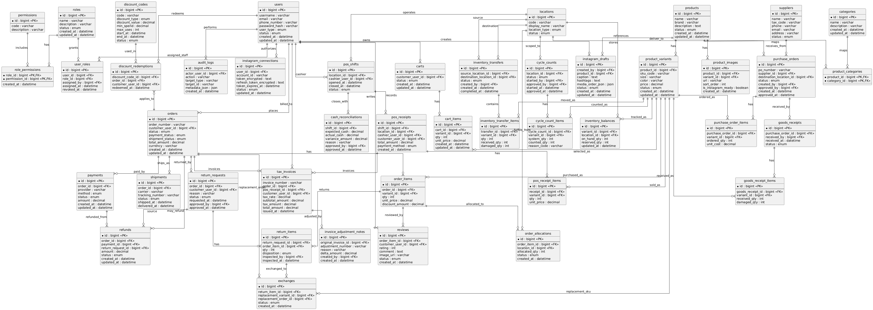
PlantUML Diagram

